ONEWAY Acc BY Gender1
/STATISTICS DESCRIPTIVES HOMOGENEITY WELCH
/PLOT MEANS
/MISSING ANALYSIS.

Oneway

Notes
Output Created |  | 05-May-2019 23:10:03
Comments
Input | Active Dataset | DataSet0
Input | Filter | <none>
Input | Weight | <none>
Input | Split File | <none>
Input | N of Rows in Working Data File | 30
Missing Value Handling | Definition of Missing | User-defined missing values are treated as missing.
Missing Value Handling | Cases Used | Statistics for each analysis are based on cases with no missing data for any variable in the analysis.
Syntax |  | ONEWAY Acc BY Gender1  /STATISTICS DESCRIPTIVES HOMOGENEITY WELCH  /PLOT MEANS  /MISSING ANALYSIS.
Resources | Processor Time | 00 00:00:00.157
Resources | Elapsed Time | 00 00:00:00.161

[DataSet0]

Descriptives
 | N | Mean | Std. Deviation | Std. Error | 95% Confidence Interval for Mean
 |  |  |  |  | Lower Bound | Upper Bound
Female | 6 | 74.5000 | 15.44992 | 6.30740 | 58.2863 | 90.7137
Male | 24 | 99.9167 | 25.29980 | 5.16430 | 89.2335 | 110.5998
Total | 30 | 94.8333 | 25.60722 | 4.67522 | 85.2714 | 104.3952

Descriptives
 | Minimum | Maximum
Female | 50.00 | 90.00
Male | 57.00 | 150.00
Total | 50.00 | 150.00

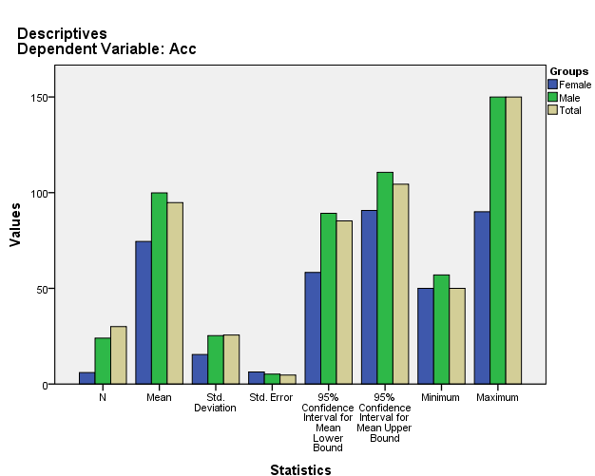

Test of Homogeneity of Variances
Acc
Levene Statistic | df1 | df2 | Sig.
3.247 | 1 | 28 | .082

ANOVA
Acc
 | Sum of Squares | df | Mean Square | F | Sig.
Between Groups | 3100.833 | 1 | 3100.833 | 5.455 | .027
Within Groups | 15915.333 | 28 | 568.405
Total | 19016.167 | 29

Robust Tests of Equality of Means
Acc
 | Statisticª | df1 | df2 | Sig.
Welch | 9.721 | 1 | 12.709 | .008
a. Asymptotically F distributed.

Means Plots

